
PRESS RELEASE Prague, 7 February 2019

Link and Breakfast, or Let’s get to know one another in BB Centrum

The first breakfast in the new series of Link and Breakfast events took place on Thursday, 24 January in BB Centrum in Prague - Michle. The directors and executives of the companies located in this complex gathered together in KOBE Restaurant in order to get to know one another and to develop closer relationships in an informal environment. The event was organised by PASSERINVEST GROUP, which was represented at the breakfast by its founder and CEO, Radim Passer.
The goal of the new Link and Breakfast event is for the individual tenants of BB Centrum to get to know one another closer, to get an idea of their businesses in an informal manner and to help them get new contacts. Twelve directors or top managers of the companies headquartered in BB Centrum participated in the first meeting, with companies such as UniCredit Bank, ABB and Microsoft sending representatives.
The event was started personally by Radim Passer, followed by a short presentation by Xerox and then the floor was open for informal talks and discussions.
“We are pleased to offer our tenants new services and to make their stay in BB Centrum more pleasant. We would like to turn the informal breakfasts for tenants into a long-term tradition, thereby opening new opportunities for people to meet, get to know one another and get contacts,” Vladimír Klouda, the Executive Officer of PASSERINVEST GROUP, commented on the event.
In light of the event’s success, it is expected to be repeated regularly, twice a year. The next Link and Breakfast should take place in the autumn.

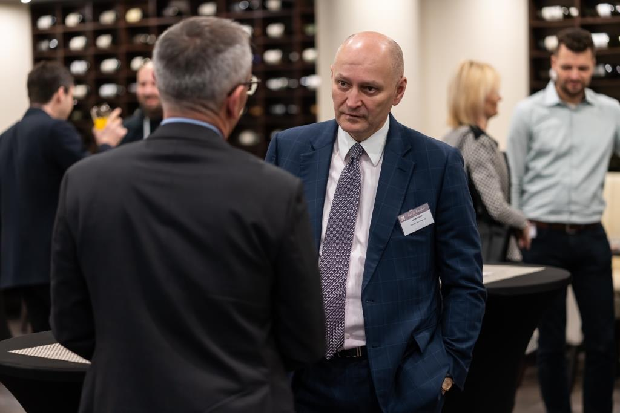

Radim Passer, Founder and CEO of PASSERINVEST GROUP, in a discussion with an event participant

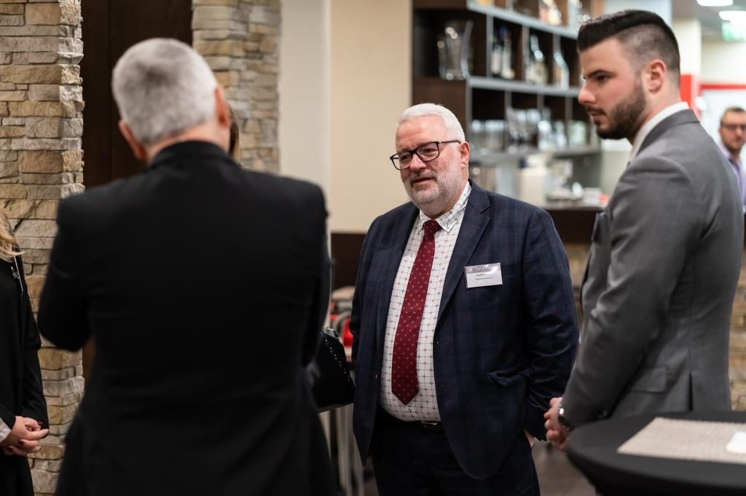

Vladimír Klouda, Executive Officer of PASSERINVEST GROUP, in a discussion with event participants

You can get more information and photographs in print quality from:
Kristýna Samková, Head of PR and Marketing Department
PASSERINVEST GROUP, a.s.
Tel.: (+420) 221 582 111
Mobile: (+420) 602 186 708
E-mail: Kristyna.Samkova@Passerinvest.cz
www.passerinvest.cz, www.bbcentrum.cz

Marcela Štefcová
Crest Communications a.s.
Mobile: (+420) 731 613 669
E-mail: marcela.stefcova@crestcom.cz

About the developer

PASSERINVEST GROUP, a. s. is a purely Czech development and investment company, whose name is primarily connected with the realisation of the multifunctional BB Centrum complex in Prague 4 – Michle. The company, established by Radim Passer in 1991, built a very good reputation both on a local and international level with this, the most successful and extensive project of its kind in Central Europe. This is not only to the credit of the quality of the realised projects and the high level of the provided services, but also due to the sense of fair play, an accommodating relationship with the buildings’ tenants/users and responsibility to the society and the environment. PASSERINVEST GROUP also has other interesting development projects in its portfolio.

