

**PRESS RELEASE** Prague, 17 October 2018

**Elijáš Christian School in BB Centrum newly opens Lyceum**

**The Elijáš Christian high school, elementary school and preschool located in the multifunctional BB Centrum complex in Prague 4 has expanded its offer of education with a third level in this school year. In September the gates of the school opened for the first time for high school students, who have the opportunity to study at the Lyceum here, oriented on humanities and natural sciences and to complete it after four years with a school-leaving exam.**

The Elijáš Christian School has already been operating in BB Centrum for ten years, and on the occasion of this anniversary it decided to expand the portfolio of educational opportunities to offer high school education. The combined lyceum, as a four-year field of study with matriculation, provides students with a complete general education, which includes the teaching of languages, mathematics, natural and social sciences and financial literacy. In the third year of studies the students can choose from a focus on humanities or natural sciences, thanks to which their education will expand to include subjects to deepen their aesthetic, ecological and moral sentiments. One new first year class for a maximum of twenty students will be opening each year.

The school has modern equipment necessary for a quality education, comfortable classrooms and its own gymnasium. At the beginning of September a new school pavilion was opened in its immediate vicinity, providing a school cafeteria cooking exclusively vegetarian meals and several club rooms. The majority of the pavilion’s rooms are multifunctional and can be used as after-school facilities for younger students as well as clubrooms or places for informal gatherings of students and teachers. The pavilion garden is adjacent to an athletic stadium meant for outdoor sporting activities and for the general public.

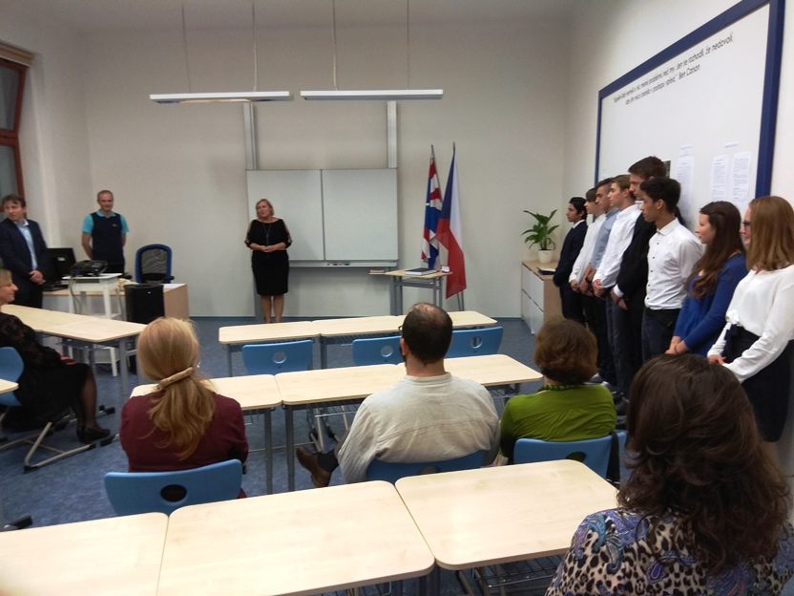

*Matriculation of students of Elijáš Christian School Lyceum*

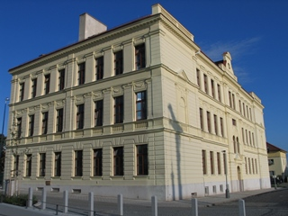

*Elijáš Christian elementary and high school*

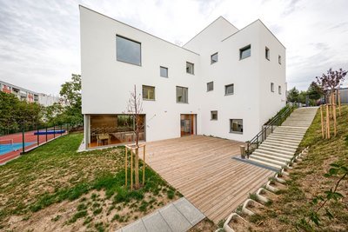

*New school pavilion of Elijáš Christian School*

You can get more information and photographs in print quality from:

Kristýna Samková**,** Head of PR and Marketing Department

**PASSERINVEST GROUP, a.s.**

Tel.: (+420) 221 582 111

Mobil: (+420) 602 186 708

E-mail: [Kristyna.Samkova@Passerinvest.cz](mailto:Kristyna.Samkova@Passerinvest.cz)

www.passerinvest.cz, [www.bbcentrum.cz](http://www.bbcentrum.cz)

Marcela Štefcová

**Crest Communications a.s.**

Mobil: (+420) 731 613 669

E-mail: marcela.stefcova@crestcom.cz

**About the developer**

**PASSERINVEST GROUP**, a. s., is a purely Czech development and investment company, whose name is primarily connected with the realisation of the multifunctional **BB Centrum** complex in Prague 4 – Michle. The company, established by Radim Passer in 1991, built a very good reputation both on a local and international level with this, the most successful and extensive project of its kind in Central Europe. This is not only to the credit of the quality of the realised projects and the high level of the provided services, but also due to the sense of fair play, an accommodating relationship to the buildings’ tenants/users and responsibility to the society and the environment. **PASSERINVEST GROUP** also has other interesting development projects in its portfolio.